**Informed Consent**

**Invitation to Take Part**  
Thank you for considering to take part in this study conducted by Benjamin Tribe and Dr Dominique Makowski from the University of Sussex (see contact information below).

**Why have I been invited and what will I do?**  
The goal is to study experience and performance on two different presentations of a simple reaction time task. The whole experiment will take you **DURATION ESTIMATE TBC** to complete. Please make you sure that you are **attentive and in a quiet environment**, and that you have time to complete it in one go.

**What will happen to the results and my personal information?**  
The results of this research may be written into a scientific publication. Your anonymity will be ensured in the way described in the consent information below. **Please read this information carefully** and then, if you wish to take part, please acknowledge that you have fully understood this sheet, and that you consent to take part in the study as it is described here.

**Consent**

* I understand that by signing below I am agreeing to take part in the University of Sussex research described here, and that I have read and understood this information sheet
* I understand that my participation is entirely voluntary, that I can choose not to participate in part or all of the study, and that I can withdraw at any stage without having to give a reason and without being penalized in any way (e.g., if I am a student, my decision whether or not to take part will not affect my grades).
* I understand that since the study is anonymous, it will be impossible to withdraw my data once I have completed it.
* I understand that my personal data will be used for the purposes of this research study and will be handled in accordance with Data Protection legislation. I understand that the University's Privacy Notice provides further information on how the University uses personal data in its research.
* I understand that my collected data will be stored in a de-identified way. De-identified data may be made publicly available through secured scientific online data repositories.
* By participating, you agree to follow the instructions and provide honest answers. If you do not wish to participate or if you don't have the time, simply close your browser.

For further information about this research, or if you have any concerns, please contact Benjamin Tribe (*bmt26@sussex.ac.uk*) or Dr Dominique Makowski (*D.Makowski@sussex.ac.uk*). This research has been approved (ER/BMT26/5) by the ethics board of the School of Psychology. The University of Sussex has insurance in place to cover its legal liabilities in respect of this study.

**Demographic Questions**

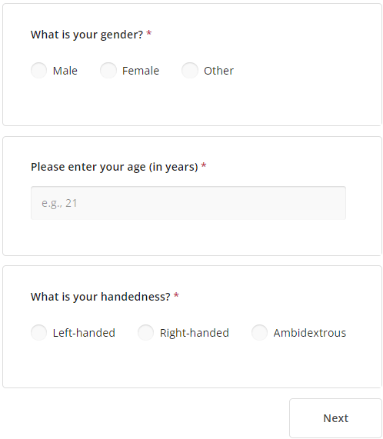

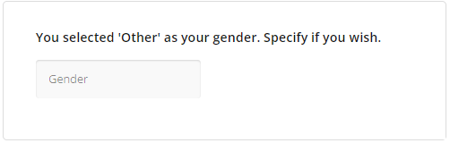

Note: The above question appears only for participants who select 'Other' for the Gender question.

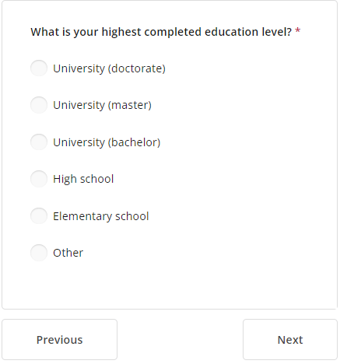

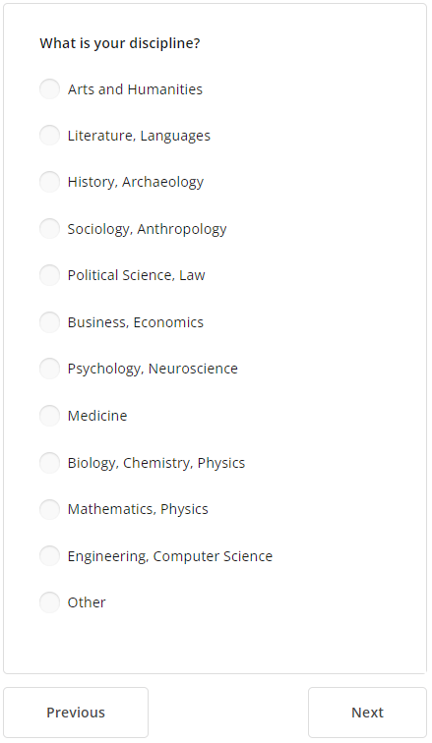

Note: The above question appears only for participants who selected one of the University options for the education level question.

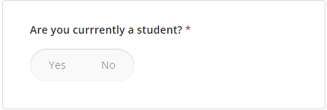

Note: The above question appears only for participants who selected Master, Bachelor or High School for the education level question.

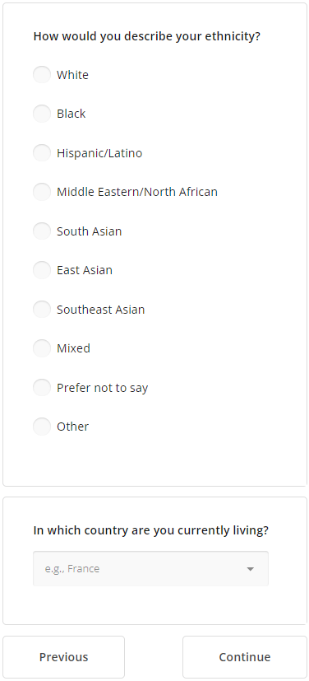

**Post experiment questions**

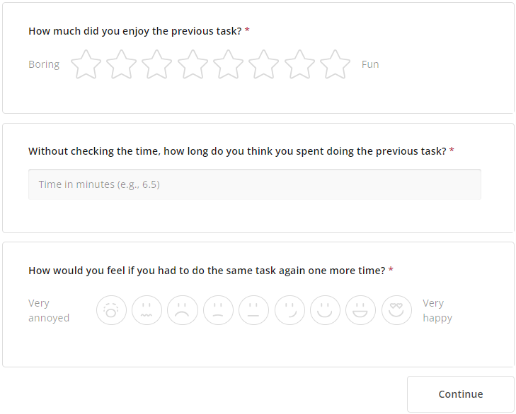

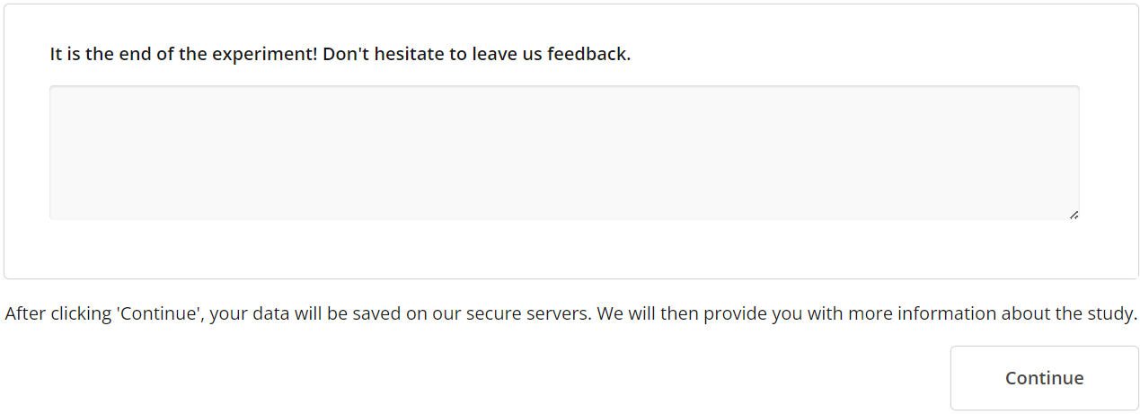

**Non-gamified Simple RT Task**

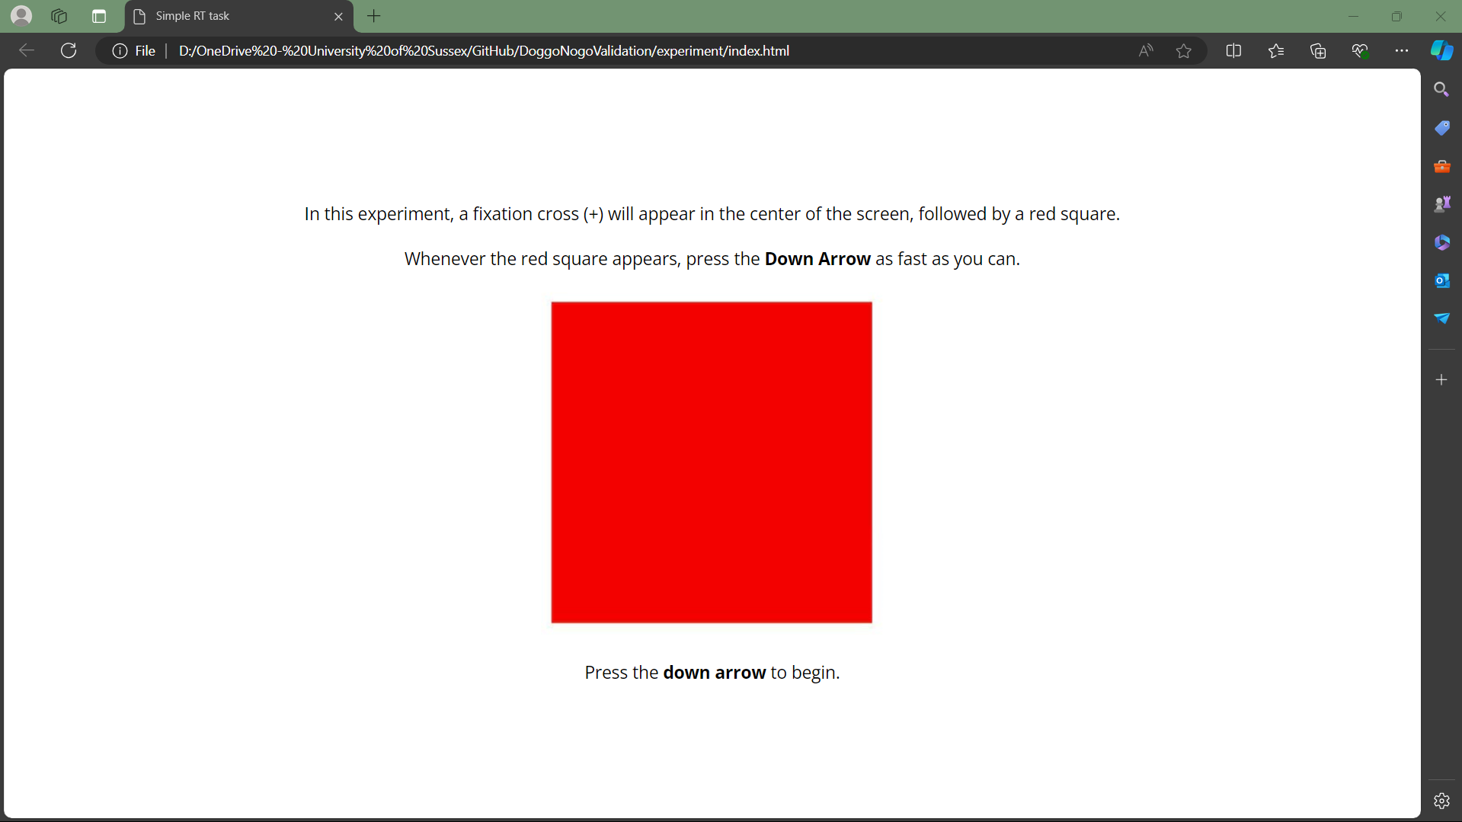

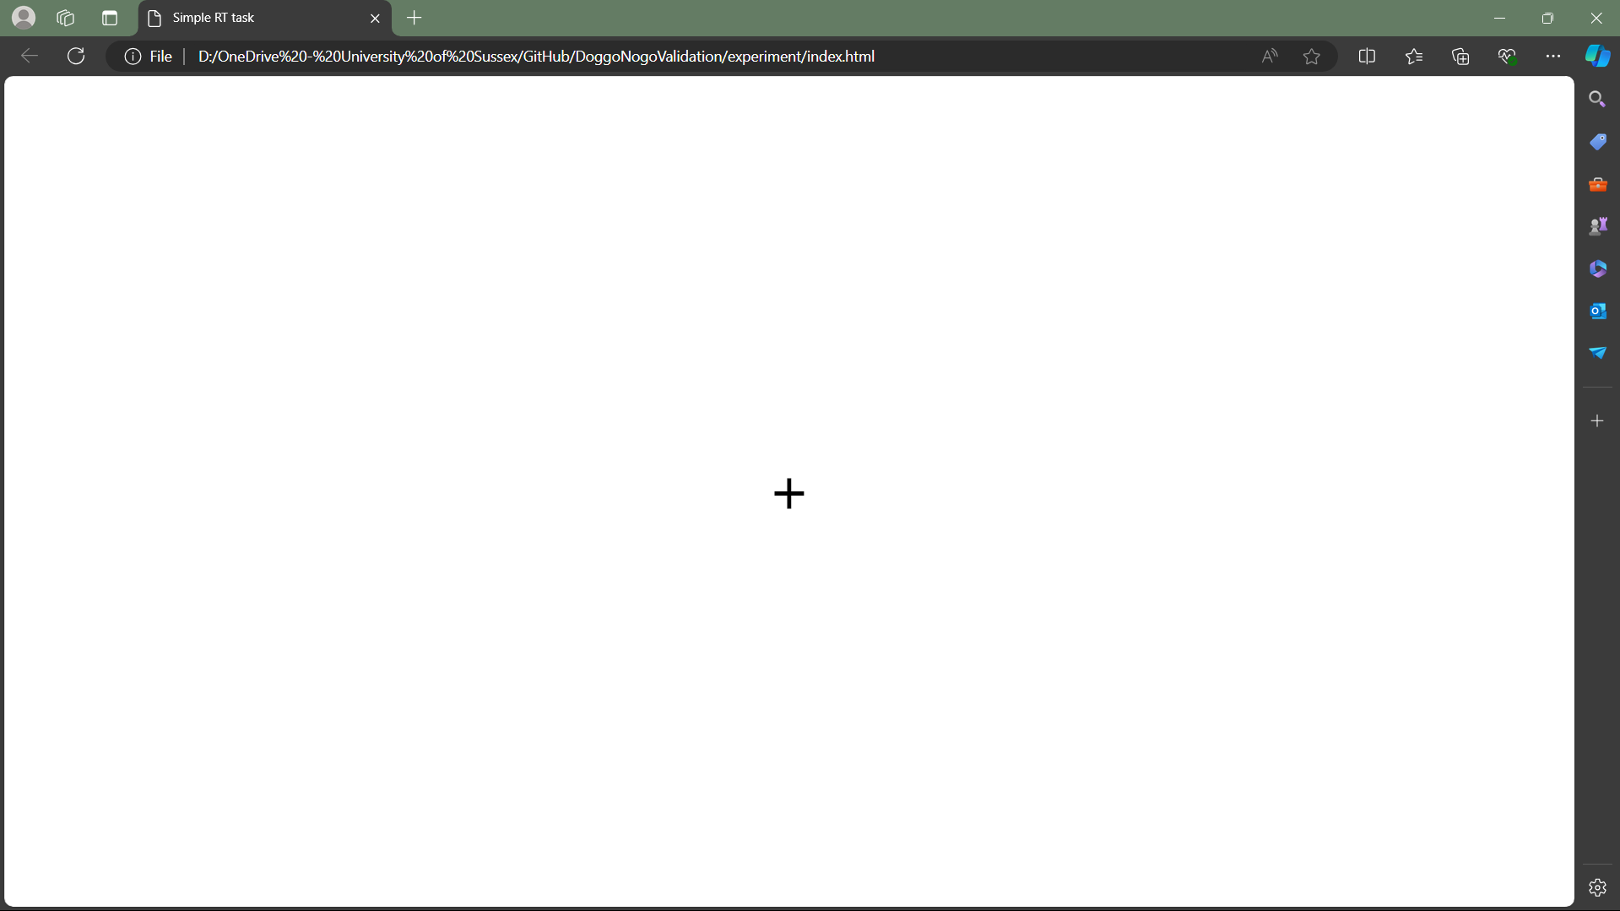

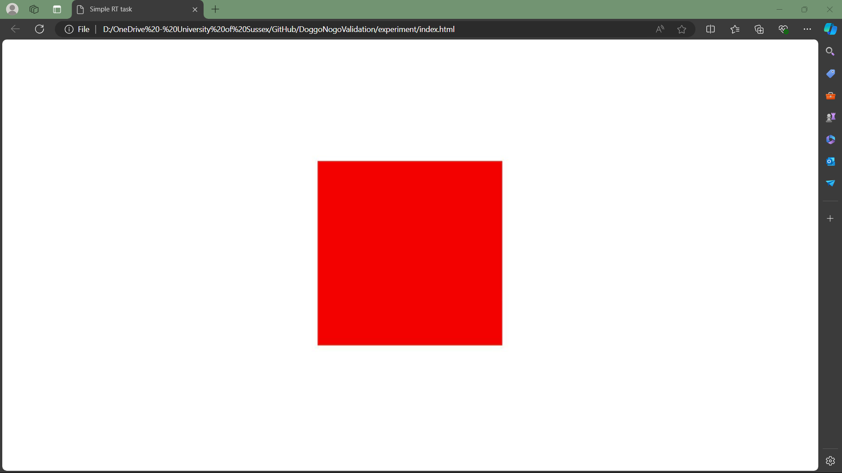

**Gamified Simple RT Task**

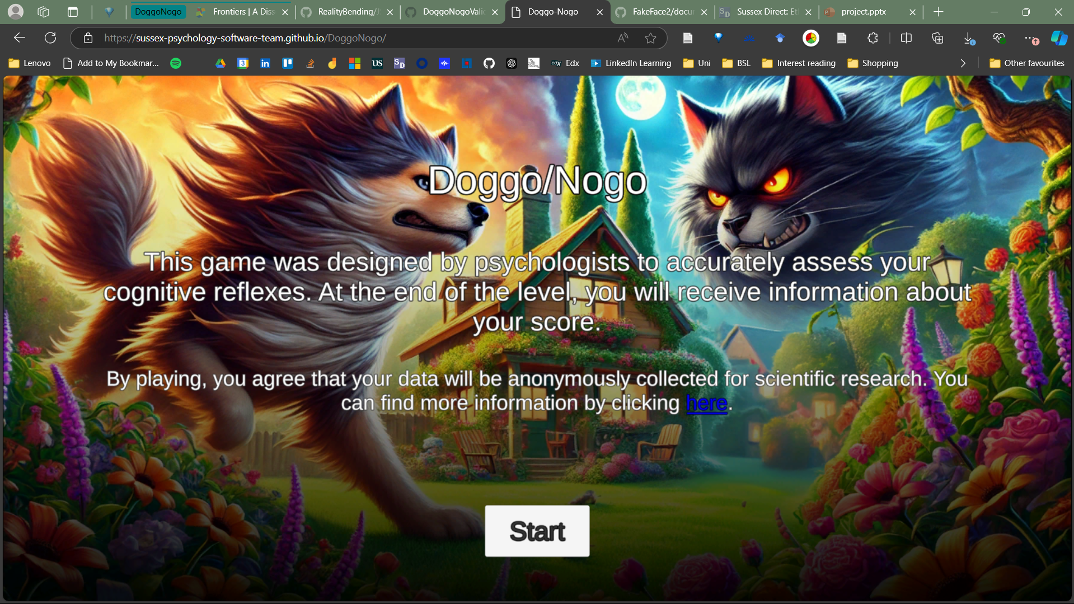

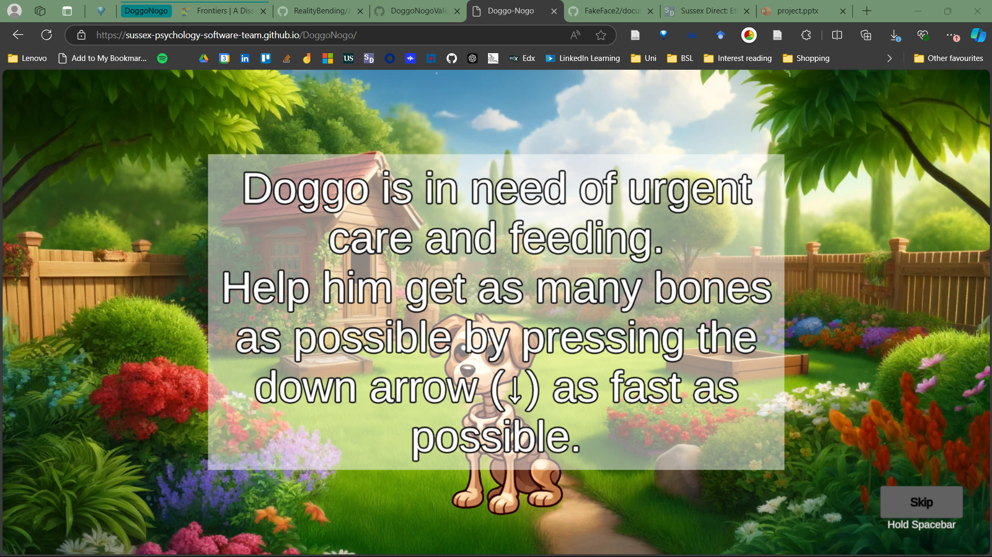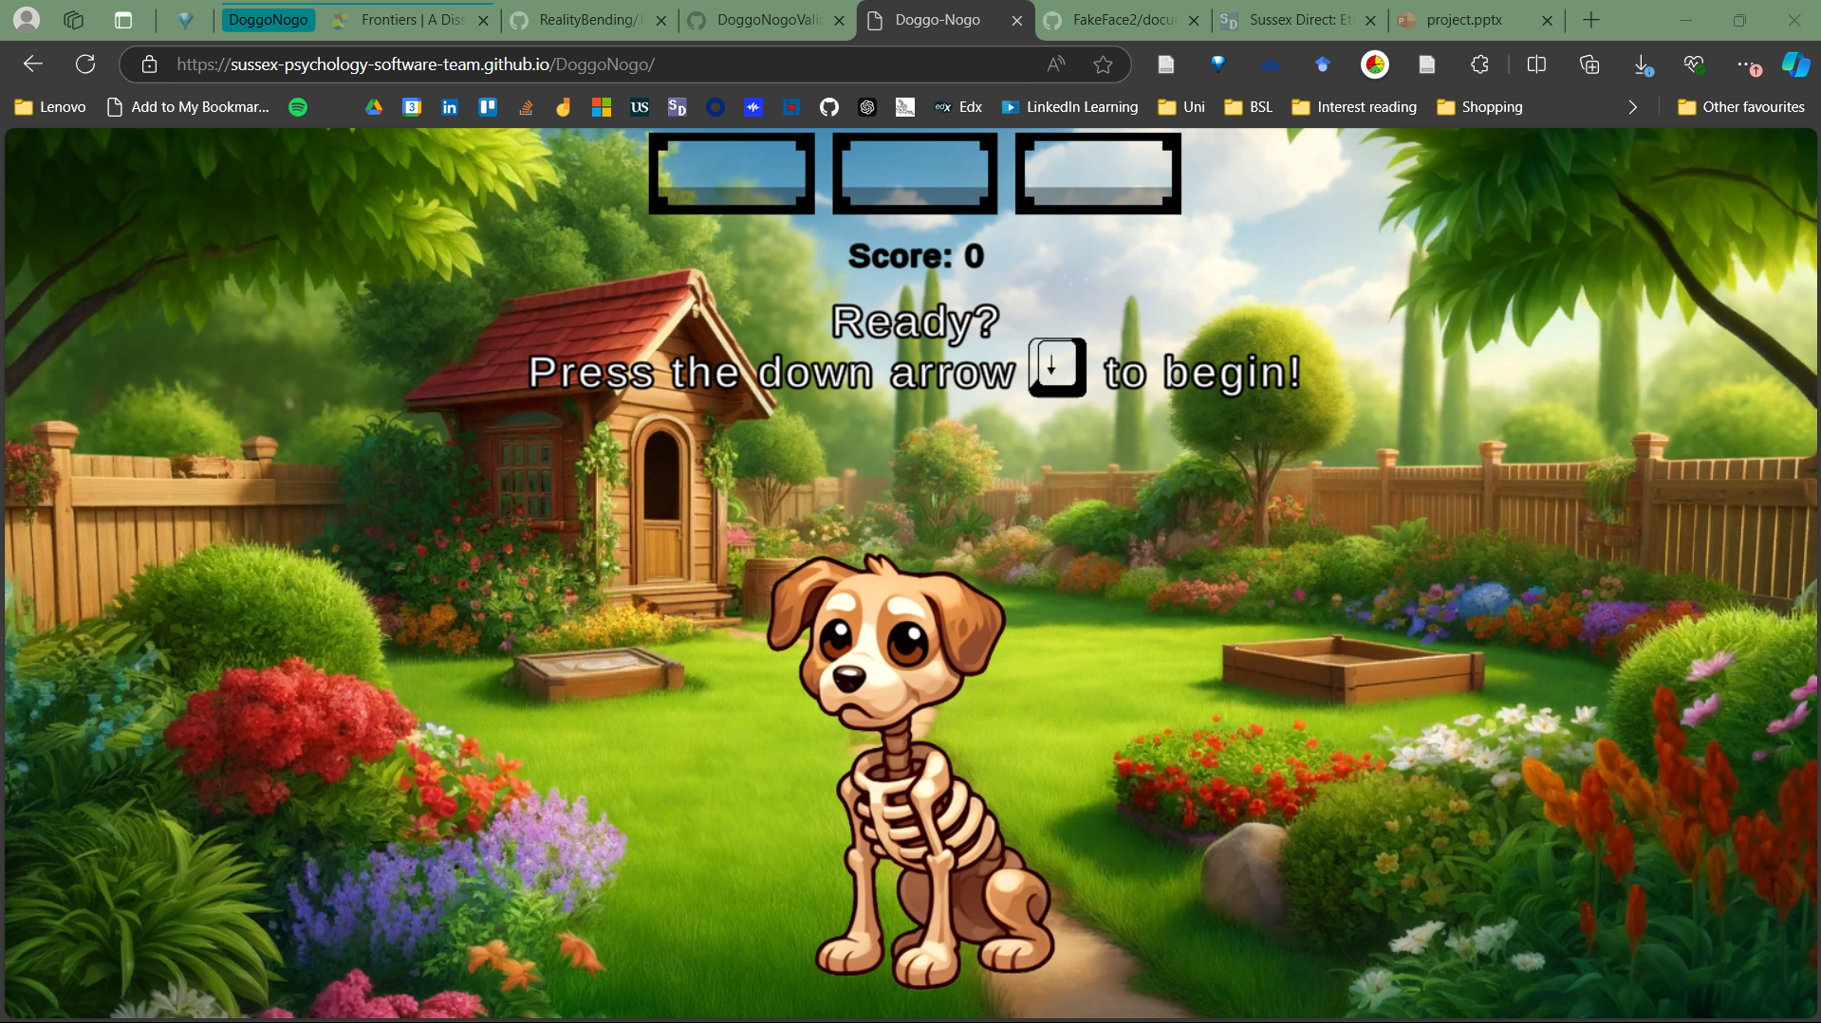

Participants receive feedback on each trial as well as if they respond prematurely:

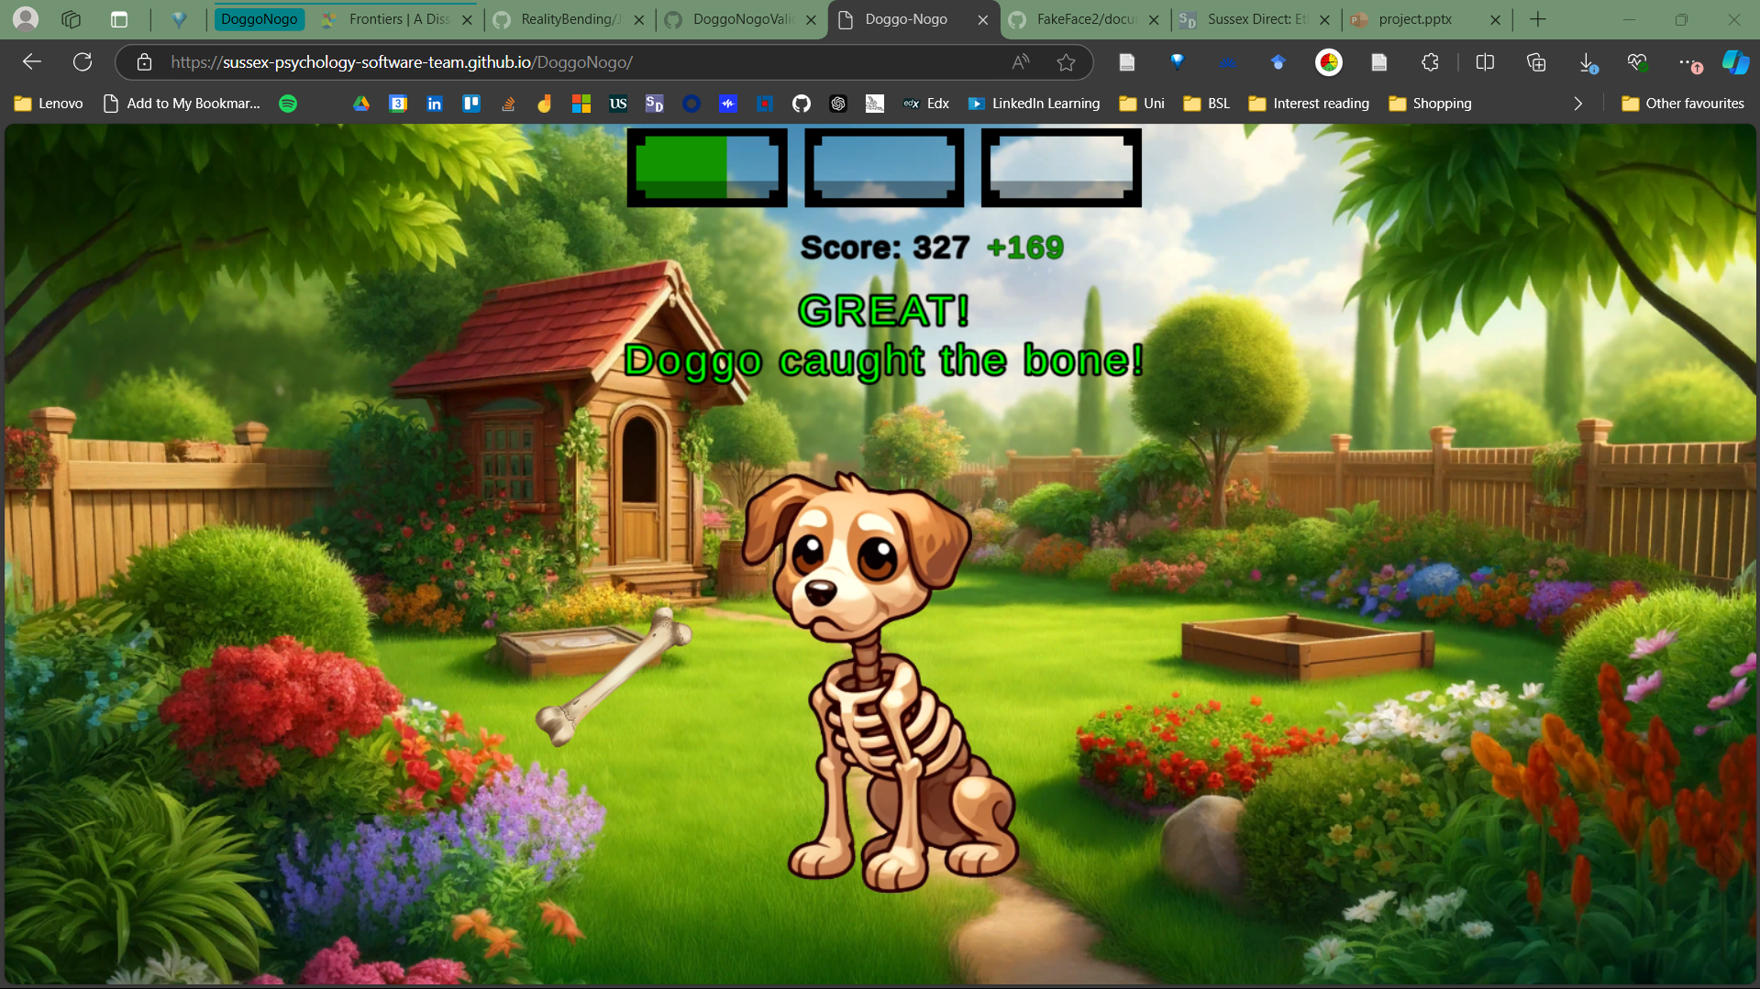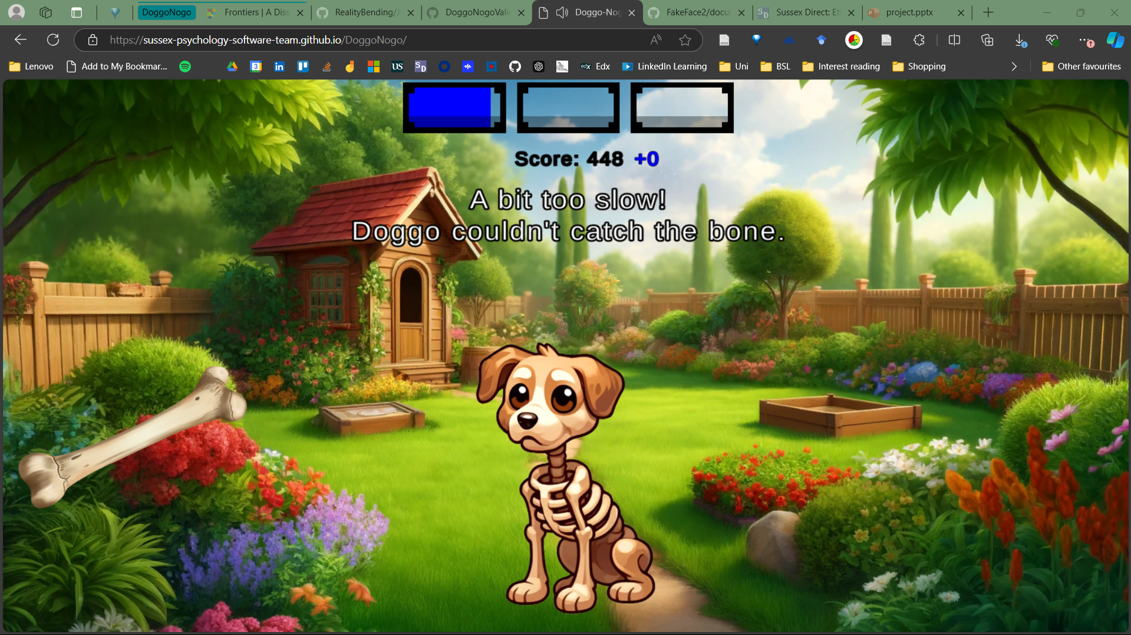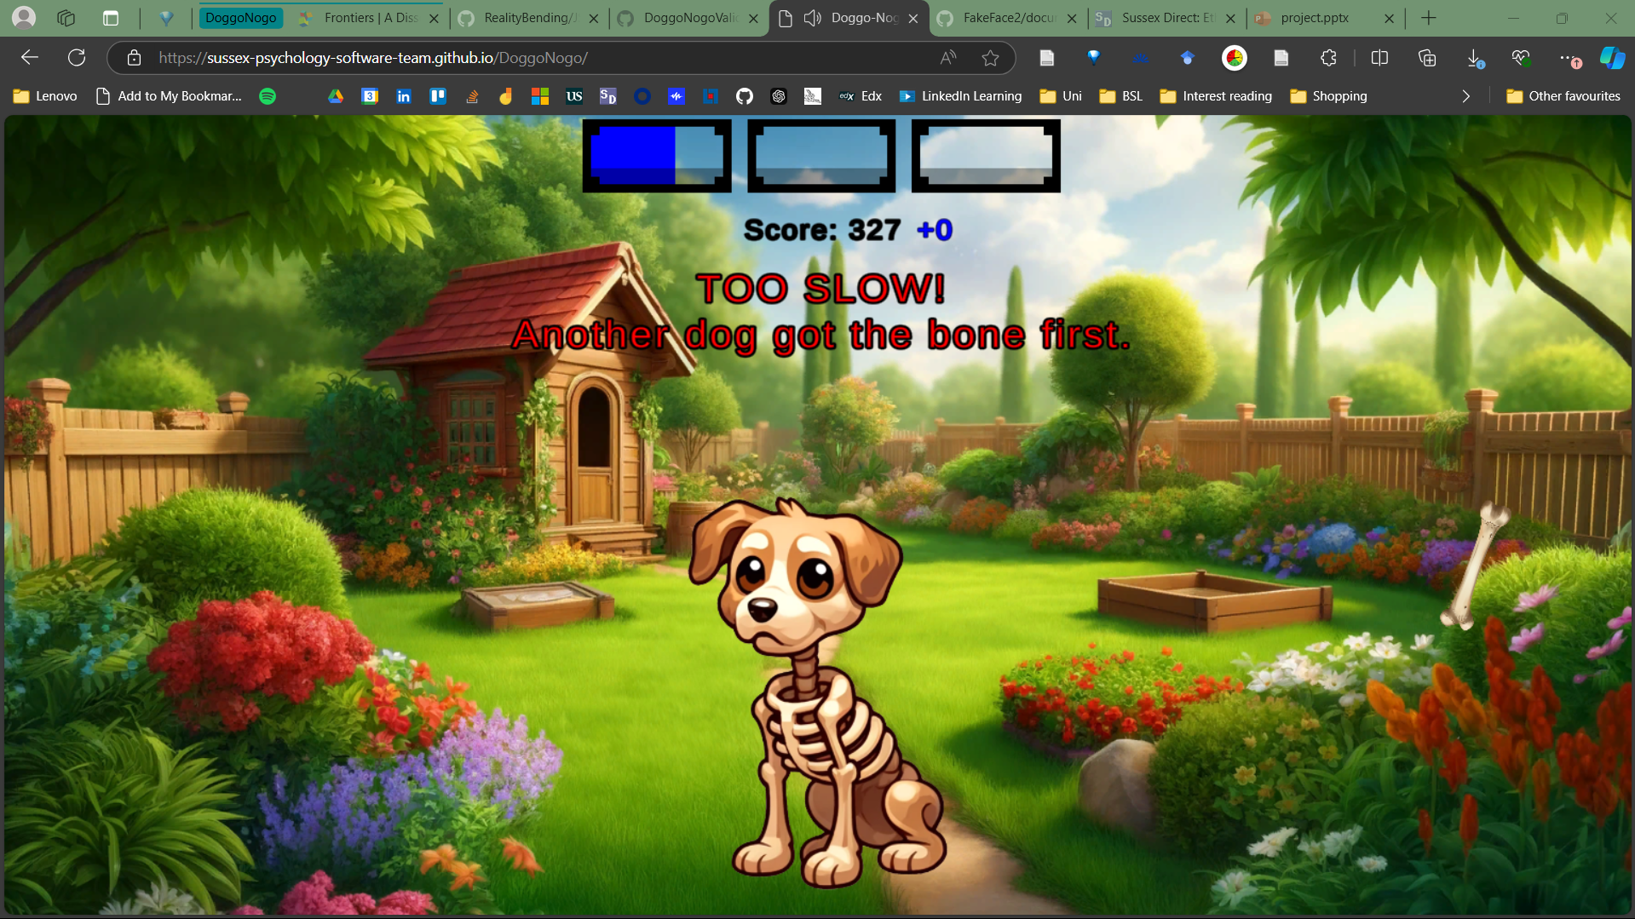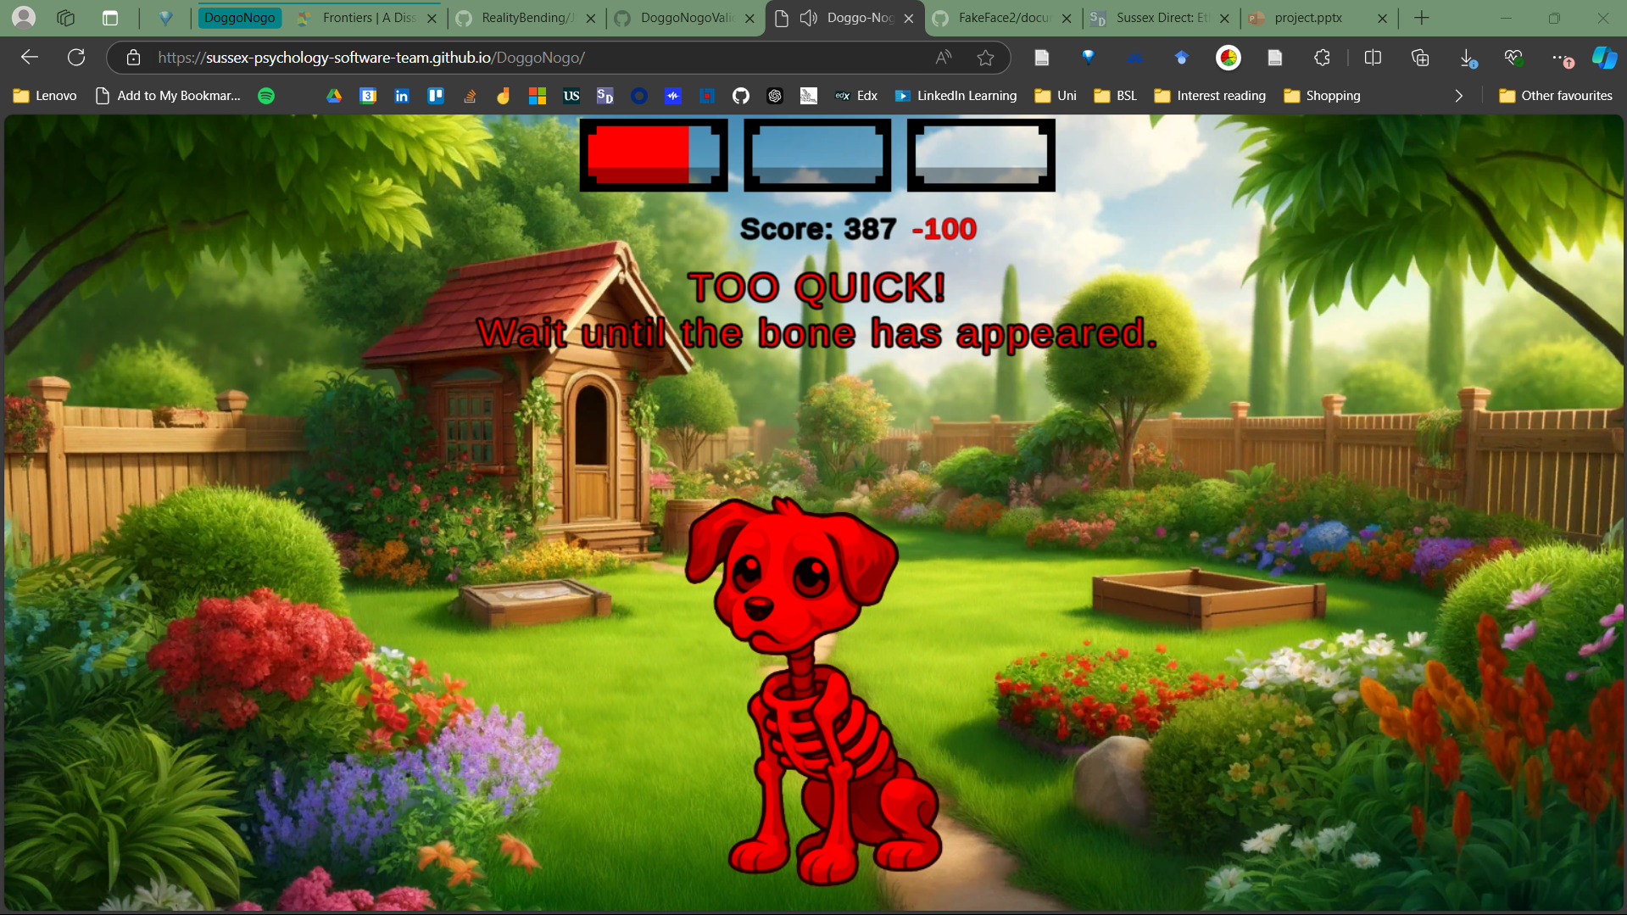

**Debriefing**

